Transfer function --:> direct form 2 structure

Draw in speedster a block diagram

Seepig the transfer function of b and a in speedster

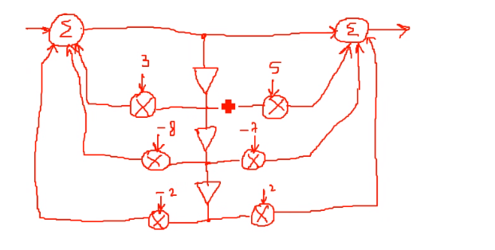

Right hand clicks and create subsystem to make the above neat and into 1 block called subsystem

Provided speed signal block

Output goes to a signal analyser also make sure to add a loud speaker signal

Dual input scopes Anush loves the most

Enabler can be added to choose whether to only hear it or only see it so if set both to1 then they should both work at the same time

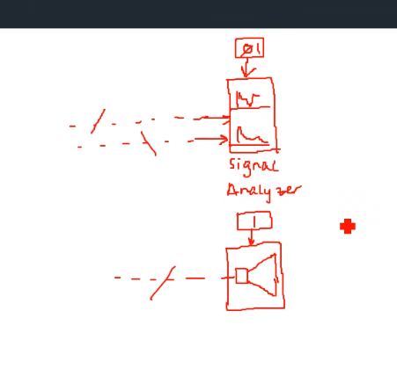

To test our model input, dspc sound source file from speedster library

Observe scope trace and spectral trace to see what will be done next with it